

COLLEGE CODE – 0001
COLLEGE NAME – COLLEGE OF ENGINEERING GUINDY
DEPARTMENT - COMPUTER SCIENCE ENGINEERING
STUDENT NM-ID - 6399E92F09068B78D4A44CBF0A1D13D6
ROLL NO - 2023103541
DATE – 30/09/2025

Completed the project named as
Phase – 2
Solution Design & Architecture
NAME : LOGIN AUTHENTICATION SYSTEM

SUBMITTED BY,

NAME - VIJAY ANANDAN J M
MOBILE NO – 7871648764

LOGIN AUTHENTICATION SYSTEM – SOLUTION DESIGN & ARCHITECTURE

TECH STACK FOR LOGIN AUTHENTICATION SYSTEM :

- Frontend:
- React.js – Dynamic and maintainable user interface.
- Tailwind CSS – Responsive, consistent styling.
- Axios / React Query – Secure API requests and data handling.
- React Hook Form– Form validation and error handling.

- Backend:
- Node.js + Express.js / NestJS – High-performance, modular backend.
- JWT (Access & Refresh Tokens) – Token-based authentication.
- Passport.js / OAuth2.0 – Social login (Google, GitHub).
- Bcrypt / Argon2 – Secure password hashing.
- Helmet.js & Rate Limiting – Protection against attacks.

- Database & Session Management:
- MongoDB – Store user credentials and roles.
- Redis – Session caching and token management.

- Security & Compliance:
- Secure JWT Storage (HttpOnly Cookies) – Prevent XSS/CSRF attacks.
- Two-Factor Authentication (2FA, optional) – OTP via email/SMS or authenticator apps.
- Data Encryption (AES/TLS) – Protect sensitive data in transit and at rest.

UI STRUCTURE / API SCHEMA DESIGN :

UI Structure :
- Registration Page – Email, Password, Confirm Password fields.
- Login Page – Email & Password form with “Forgot Password”.
- Forgot Password Page – Enter email, receive reset link.
- Reset Password Page – Enter new password and confirm.
- Dashboard (Protected) – Accessible only with valid JWT session.
- Navbar – Shows “Login/Register” or “Profile/Logout” depending on session.
API Schema :
- POST /api/auth/register - Registers a new user.
- POST /api/auth/login - Logs in a user and returns a JWT token.
- POST /api/auth/forgot-password - Sends a password reset link to the user’s email.
- POST /api/auth/reset-password - Resets the user’s password using a valid reset token.
- GET /api/auth/me - Fetches the logged-in user’s profile.
- POST /api/auth/logout - Logs out the user by invalidating the token/session.

DATA HANDLING APPROACH :

Registration Flow
- User submits registration form.
- Backend validates email uniqueness, hashes password, stores user.
- Confirmation email with verification link is sent.
Login Flow
- User enters email & password.
- Backend verifies credentials → issues JWT token with expiry.
- Client stores JWT in HttpOnly cookie.

Password Reset Flow
- User requests reset link via email.
- Link expires after fixed duration (e.g., 1 hour).
- User sets new password (hashed before storing).
Protected Routes
- Client includes Authorization: Bearer <JWT> in request header.
- Middleware validates token → grants or denies access.
Logout Flow
- Stateless JWT: client removes token.
- (Optional) Redis can blacklist tokens for extra control.

COMPONENT/ MODULE DIAGRAM :
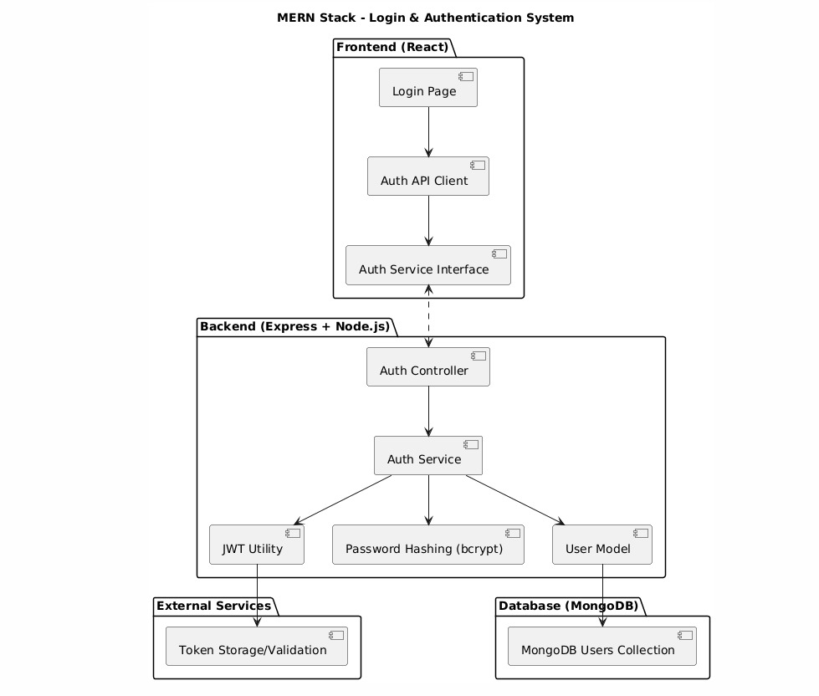

FLOW DIAGRAM :
